Supplies:
- White card stock
- Crayons or markers
- Glitter or glitter glue (optional)
- Scissors
- Glue or glue stick
Directions:
- Print the template below.
- Color and decorate the hearts.
- Have the child pick the message they want for the back of the valentine and have them color that message.
- Cut out all pieces.
- Fold arm and leg strips like an accordion.
- Glue arm and leg strips onto the big heart.
- Glue small hearts on for hands and feet.
- Glue the message below to the back of the heart.

Have students give to parents or leave in the car as a reminder to all those you love to wear their seat belt for every car ride.

Talk to your students about the importance of seat belts. Key messages to talk about:

Seat Belt Use Safety Tips
- Always buckle up — and insist passengers are belted, too. In a crash, unbelted motorists can become a projectile, slamming into and injuring or killing others inside a vehicle.
- Wear lap belts low and snug across the hips; shoulder straps should never be tucked under an arm or behind the back — not only is this unsafe, but it is also illegal.
- Children under age 13 should always ride in the back seat. Kids under 4-feet 9-inches should be in a booster seat. Learn more about the child passenger safety and the booster seat law. It is recommended to keep a child in a booster seat based on their size rather than their age. The booster seat must be used with a lap and shoulder belt. The child is ready for an adult seat belt when they can sit with their back against the vehicle seat, knees bent comfortably and completely over the vehicle seat edge without slouching, and feet touching the floor.

- Airbags are designed to work with seat belts to keep vehicle occupants in a safe position during a crash — airbags are not effective when the motorist is not belted.

Below you will find a link to some videos to share with the students.

Some videos you can show:

Let’s Buckle Up | Car Safety for Kids | Seat Belt Song | Good Habits | Kindergarten Song | JunyTony - YouTube

Seat Belt Song for Kids | Seat Belt Safety Song for Children | Fun Kids English - Bing video

Learning road safety education resources, seat belt for kids - Bing video

What If You Didn't Wear Your Seatbelt? ft. TheOdd1sOut - Bing video

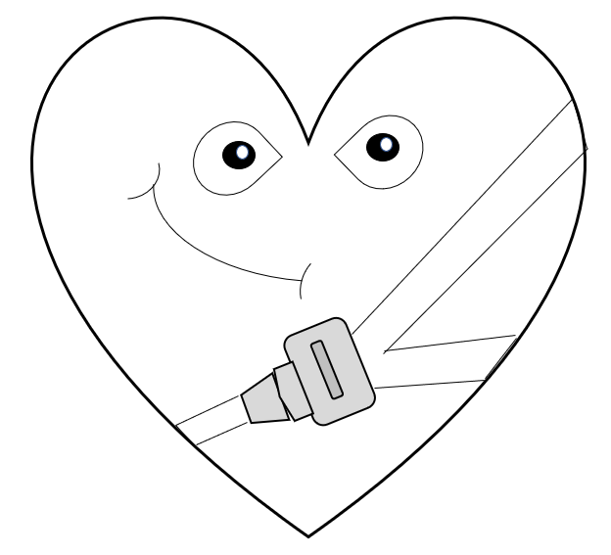

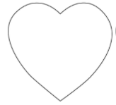
I think we click
I think we click
Someone
Loves you
Someone
Loves you

Someone Loves You
Buckle Up!

OR

I Think
We
Click!

