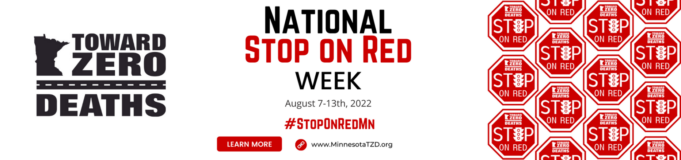

What is the Minnesota Toward Zero Deaths
Stop on Red Week Campaign Toolkit?

National Stop on Red Week serves as an important reminder of the dangers in intersections and the importance of stopping on red. This includes stop lights, stop signs, and at railroad crossings. Preventing these crashes is in each driver’s control. Together, we can protect our community, families, and friends by ALWAYS STOPPING on RED.

Please join us August 7 - 13th, 2022, to spread our message of driving safe for the ones we love. To assist you with this endeavor, here are campaign communication tools ready to adapt and use during Stop on Red Week:

- Email Template
Adapt the greeting and closing, and then send out to your distribution lists on “TZD Tuesday” during the week of the campaign, Tuesday, August 9th.

- Newsletter Article Template & Letter to the Editor
These templates are provided to help you communicate about Stop on Red Week. Send out to your distribution lists to inform them about this campaign or ask your local newspapers to share.

- Social Media Posts
Follow the social media daily template for consistent messaging and use the Facebook cover during the week of the campaign to capture a visual interest.

- Additional Materials, including a poster & JPEG
Print the poster to give out personally or distribute with your partners. Share the JPEG image on your social media platforms or publish in newsletters or personalized emails and letters. Visit your local eateries, clinics, libraries, or any other local businesses and ask if they would be willing to display these items or give out these materials to their patrons.

Thank you for your participation!
For additional tools and resources,
please check out our website at: www.minnesotatzd.org.

