Social Media Daily Template
How to use these social media posts: Share from the MN TZD social media pages (Facebook or Twitter) or download/save images to create your own post!
Each day has a theme listed and sample social media post. After downloading the graphic (do not copy/paste the graphics included on this template due to low resolution quality. For the best results, download the social media post needed for each day), use the theme for that day and write your post with the suggested corresponding verbiage. Remember to add fun emojis to your post too, such as stop signs, stop lights, caution signs, trains, etc. Use hashtags to help spread the message across social media and increase your reach to more audiences.
Sunday August 7th
- Theme: Introduction to Stop On Red Week
- Social Media Post:
  - 🛑 National Stop On Red Week kicks off today! Join us this week, August 7-13, for safety reminders about stop signs, stop lights and railroad crossings. Together, we can help make our streets safer by always stopping on red! You are key to intersection safety! #StopOnRedMN #StopOnRed2022 #TZDMN #TowardZeroDeaths #StopOnRed

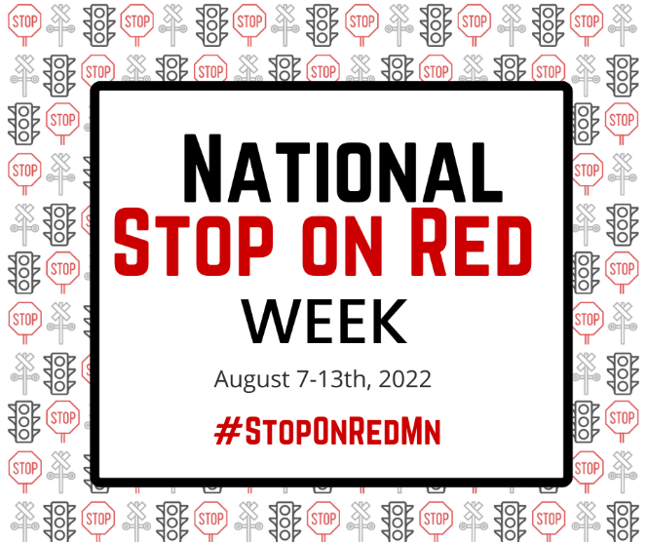

Monday August 8th
- Theme: Always Stop On Red
- Social Media Post:
  - ⚠️ Safety in Numbers. Stop on red. Help keep our intersections safe by joining the majority of people that choose to always stop on red! #StopOnRedMN #StopOnRed2022 #TZDMN #TowardZeroDeaths #StopOnRed
- Resources:
  - 2020-TSCI-Full-Report-October-2021-FINAL.pdf (aaa.com)

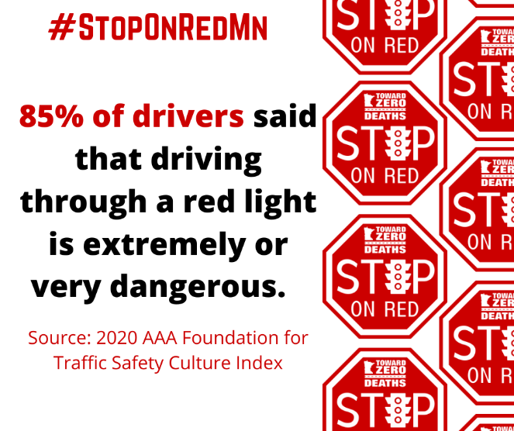

Tuesday August 9th
- Theme: Stop Signs
- Social Media Post:
  - 🛑 Stop at the stop sign. Stay behind the line! Wait until it’s clear and fine. #StopOnRedMN #StopOnRed2022 #TZDMN #TowardZeroDeaths #StopOnRed
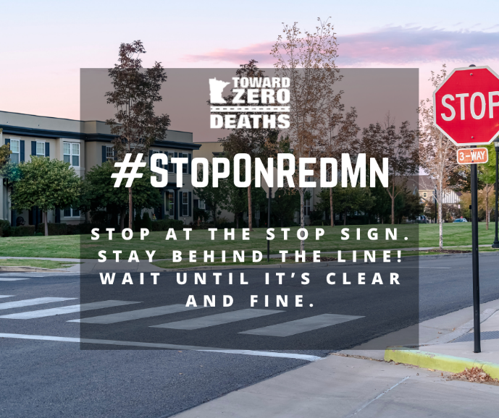

Wednesday August 10th
- Theme: Stop lights
- Social Media Post:
- 🚦 Stop on red at the stop light. Sit tight and be polite. Wait until you see green flash bright! #StopOnRedMN #StopOnRed2022 #TZDMN #TowardZeroDeaths #StopOnRed
- Resources:
- If You Run a Red Light You Are Betting More Than You Can Afford to Lose (dot.gov)
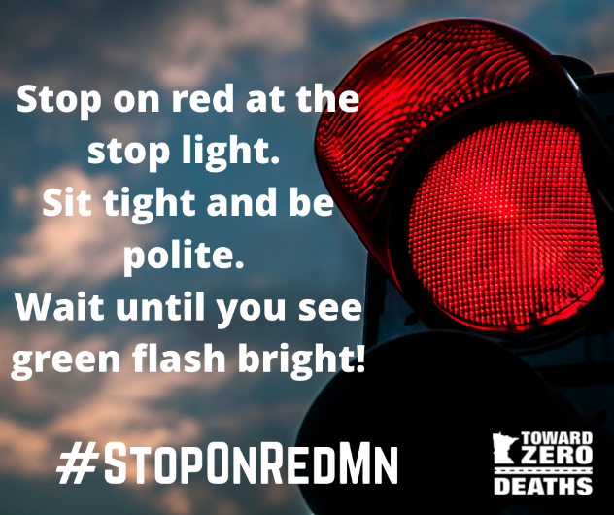

Thursday August 11th
- Theme: Railroad
- Social Media Post:
- 🚂 Stop. Trains can’t. At railroad crossings, trains always have the right of way. Make sure you have room to get across. Stop 15 feet away from flashing red lights, lowered gates, a signaling flagman or a stop sign. For more tips, visit @OperationLifesaverInc. #StopOnRedMN #StopOnRed2022 #TZDMN #TowardZeroDeaths #StopOnRed
- Resources:
- Operation Lifesaver
- Rail Crossing Safety for Drivers | Stop. Trains Can't. | NHTSA
- Pedestrian / Motorist | Federal Railroad Administration (dot.gov)
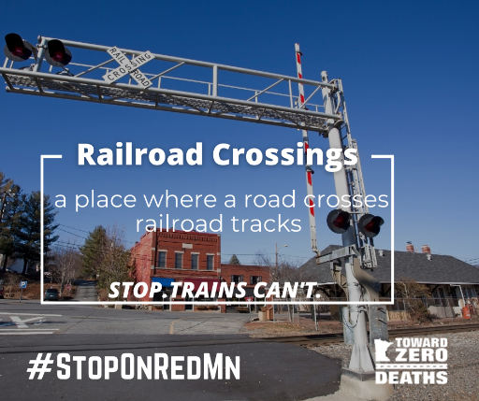

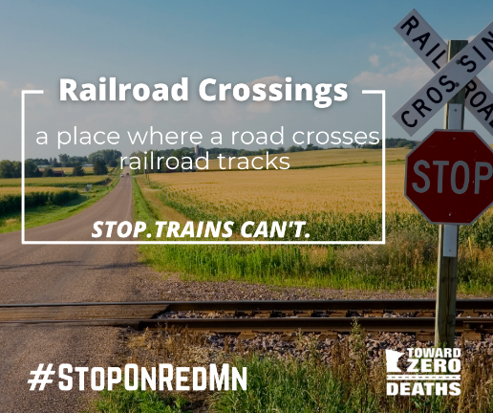

Friday August 12th
- Theme: Always Stop On Red
- Social Media Post:
- Sometimes we need reminders. Prevent a crash. 🛑🚦🚂 You are key to intersection safety. Always stop on red! #StopOnRedMN #StopOnRed2022 #TZDMN #TowardZeroDeaths #StopOnRed

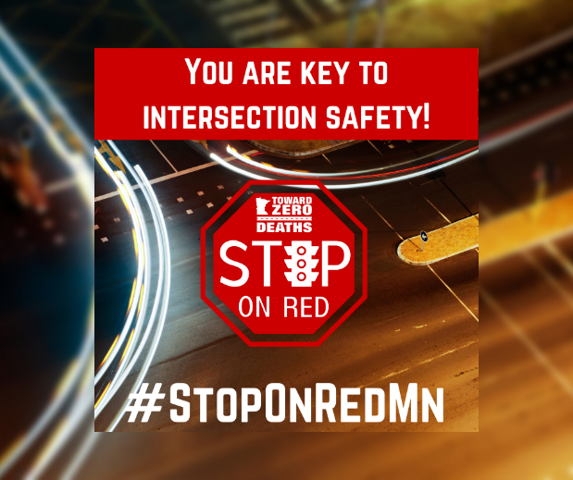

Saturday August 13th-
- Theme: Always Stop On Red
- Social Media Post:
  - Thank you for following along with us this week during Stop On Red Week and thank you for your commitment to stopping on red at stop signs, stop lights and railroad crossings! #StopOnRedMN #StopOnRed2022 #TZDMN #TowardZeroDeaths #StopOnRed
