Minnesota Teens Toward Zero Deaths Handbook
  - August 2023

Table of Contents
- Table of Contents 1
- Purpose of the Handbook 2
  - Teens Toward Zero Deaths Mission 2
- Resources and Information 3
  - Contact Information 3
  - Online Resources 4
  - Acronyms 4
- How to Get Started 5
  - Teen TZD Champions 5
  - TZD Committee 5
  - “E” Connection 5
  - Expenses 5
  - Responsibilities of TTZD 6
  - Evaluation 6
- Activities 7-11
- Teens Toward Zero Deaths Conference and TZD State Conference 12-14
  - Event Planning 12-13
  - Example Agenda 15-16
- Teen Data and Statistics 16-18
Impact Teen Drivers Presentation at Park Rapids High School – Trooper Nate Tupy

- Purpose of the Handbook
The purpose of this handbook is to provide an informational resource to assist in developing a Teens Toward Zero Deaths (TTZD) program in your local school, community, or region. This handbook outlines how to build the program as well as how to plan a regional conference. Regional conferences are designed to facilitate the implementation of TTZD in local communities and serve as a career exposition for students interested in the 4 E’s: Education, Emergency Medical Services (EMS), Enforcement, and Engineering. The goals of the TTZD program are to encourage traffic safety as a priority for teens, provide a method to bring traffic safety programs into communities, share successes of the Minnesota TTZD program, build relationships between schools, communities and the 4 E’s, and to network with other school and traffic safety advocates in the region.

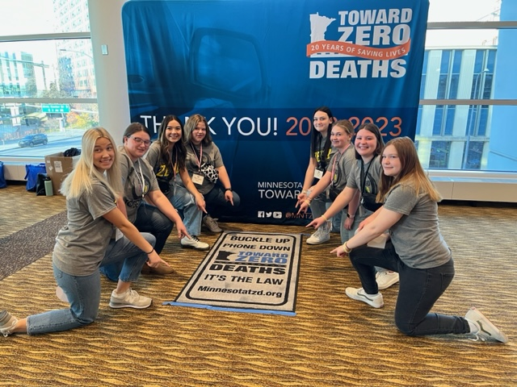

Pennington County Teens participated at the 2023 State TZD Conference in Rochester, MN on Nov 14 & 15, 2023

  - Teens Toward Zero Deaths Mission
The Teens Toward Zero Deaths mission is to create a culture in which traffic fatalities and serious injuries are no longer acceptable. TTZD educates teenage drivers and school-age pedestrians about the responsibilities of keeping our roadways safe through youth advocacy groups and partnerships with local and regional E’s. TTZD efforts will be driven by data, best practices, research, and evaluation.

- Resources and Information

  - Contact Information
Organization | Name | Title | Phone Number | Email
Lincoln High School TTZD | Rosaline  Groven | TTZD Program Coordinator | Office: 218-681-7463 #1113 | Rosaline.Groven@myprowler.org
Lincoln High School TTZD | Stacey Leake | TTZD Program Coordinator | Office: 218-681-7463 | Stacey.Leake@myprowlder.org
DPS Office of Traffic Safety | Michael  Hanson | Director and  TZD Co-Chair | Office: 651-201-7061  Cell: 763-276-0357 | Michael.Hanson@state.mn.us
DPS Office of Traffic Safety | Kat Vue | Teen Driver Safety Coordinator | Office: 651-201-7060 | kat.vue@state.mn.us
Toward Zero Deaths | Kristine Hernandez | Statewide TZD Coordinator | Office: 507-286-7601  Cell: 507-273-0677 | Kristine.Hernandez@state.mn.us
Toward Zero Deaths | Scot  Edgeworth | East Metro Regional TZD Coordinator | Cell: 651-775-9496 | Scot.Edgeworth@state.mn.us
Toward Zero Deaths | Tara  Helm | West Metro Regional TZD Coordinator | Office: 651-201-7067  Cell: 651-600-8018 | Tara.Helm@state.mn.us
Toward Zero Deaths | Sarah McGeary-DeHaan | Southwest Regional TZD Coordinator | Cell: 320-231-5195 | Sarah.McGeary-DeHaan@state.mn.us
Toward Zero Deaths | Sue  Johnson | Northwest Regional TZD Coordinator | Cell: 218-766-5943 | Susan.Marie.Johnson@state.mn.us
Toward Zero Deaths | Rahya Geisler | Northeast Regional  TZD Coordinator | Cell: 651-201-7273 | Rahya.Geisler@state.mn.us
Toward Zero Deaths | Katy  Kressin | West Central Regional TZD Coordinator | Cell: 218-849-0048 | Katy.Kressin@state.mn.us
Toward Zero Deaths | Annette  Larson | South Central Regional TZD Coordinator | Office: 507-304-6100  Cell:507-720-2101 | Annette.L.Larson@state.mn.us
Toward Zero Deaths | Bill Van Koevering | East Central Regional TZD Coordinator | Office: 507-286-7601  Cell: 507-273-0677 | bill.vankoevering@state.mn.us
Toward Zero Deaths | Jessica  Schleck | Southeast Regional  TZD Coordinator | Office: 507-286-7602  Cell: 507-696-8435 | Jessica.Schleck@state.mn.us
Updated 11/2023
  - Online Resources
- Teens Toward Zero Deaths, Lincoln High School https://www.smore.com/eyz06
- Toward Zero Deaths www.minnesotatzd.org
- Toward Zero Deaths Regions www.minnesotatzd.org/initiatives/regions
- Minnesota Department of Health www.health.state.mn.us
- Department of Public Safety, Office of Traffic Safety www.dps.mn.gov/divisions/ots
  - Educational Materials https://dps.mn.gov/divisions/ots/educational-materials/
  - Teen Driving https://dps.mn.gov/divisions/ots/teen-driving/
- Minnesota Department of Transportation http://www.dot.state.mn.us/
- Minnesota State Patrol www.dps.mn.gov/divisions/msp
- Network of Employers for Traffic Safety www.trafficsafety.org
- Impact Teen Drivers www.impactteendrivers.org

  - Acronyms
- DPS: Department of Public Safety
- DPS OTS: Department of Public Safety, Office of Traffic Safety
- EMS: Emergency Medical Services
- MDH: Minnesota Department of Health
- MnDOT: Minnesota Department of Transportation
- MnDOT OTE: Minnesota Department of Transportation, Office of Traffic Engineering
- MSP: Minnesota State Patrol
- SHSP: Strategic Highway Safety Plan
- TZD: Toward Zero Deaths
- TTZD: Teens Toward Zero Deaths
- UMN CTS: University of Minnesota, Center for Transportation Studies

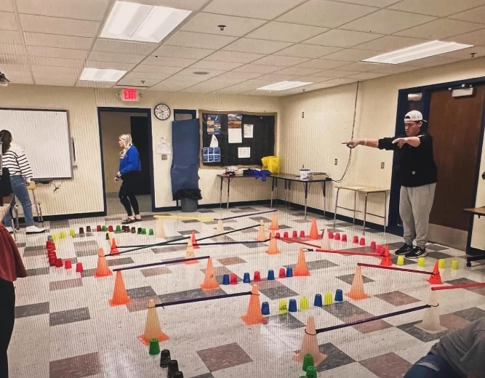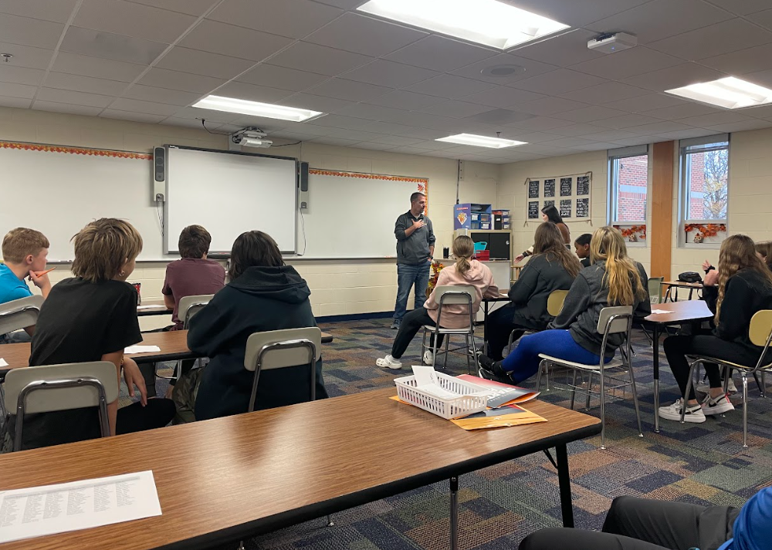

Franklin Middle School Teen TZD Conference on Oct 24, 2023
How to Get Started
  - Champions for Teen TZD
Teen TZD champions are individuals who oversee the TTZD program within the school or organization. They are usually a teacher, or someone affiliated with the school, a community civic group, or other organization. When planning to integrate a TTZD program into the school environment, look for a well-respected adult, recognized by students, who are already affiliated with a student program within the community or school. It is important to work closely with the school(s) to create a TTZD program that is recognized as being vital to the safety and education of the student body. A willingness from school leaders, students, and the community to actively support and participate in the program is important for the success of the program.
  - Teen TZD Committee
Using an established organization, such as a club or student group, within the school is an excellent way to start forming a TTZD program. Creating a subgroup within an already existing organization is an option. Look for students who want to learn more about traffic safety, who are interested in implementing a traffic safety-related campaign, or who are interested in pursuing a career path in one of the E’s.
  - “E” Connection
Whether your county has an active TZD Safe Roads Coalition or not, members of the “E” community may be a good person to reach out to before getting started. Contact your local law enforcement agency, nearest State Patrol Office, EMS Service at a local hospital or clinic, local fire department, first responders, or your city or county engineering office. These groups are a valuable resource to start a TTZD program.
  - Expenses
Below is a list of typical operating expenses for TTZD programs. The list will change depending on the activities, events, or conference planned for your community.
- Printing of materials
- Materials cost, such as paper, posters, markers, etc.
- Advertising
- Door prizes
  - Teen TZD Commitment to Safe Roads Behavior
Establishing habits within individuals takes time and repeated application. For this reason, the TTZD program needs to be more than a one-day event. An ongoing platform, within the school and community, is best to prevent teen crashes and to ensure teens are practicing positive traffic safety behaviors, such as limiting distractions while driving and always wearing a seatbelt. Find more recommendations in the “Activities” section, which are created for driver awareness as well as for passengers and pedestrians.
  - Evaluation
Applying an evaluation component within a program helps to improve the program and demonstrate accountability of invested resources. Evaluation is a process that critically examines a program to assess the quality of the program’s activities, determine if the activities are well-designed and if the activities are working to their full potential. By incorporating an evaluation, it helps to determine if adjustments are needed in the program to improve the efforts. In addition, an evaluation demonstrates to stakeholders, such as individuals supporting efforts or sponsors, that the resources that were invested into the program were worthwhile. Validating the use of resources by providing evidence that goals were met and services were delivered as promised is a program that will be viewed as successful.

Suggested Examples:
- TTZD students conduct a seatbelt survey to establish baseline data. The survey should be conducted in the Fall, prior to implementing activities. Activities focused on improved traffic safety will be implemented during the school year. In the Spring, another survey is conducted to determine if the traffic safety activities had an effect on students to improve their seatbelt rate.
- TTZD students conduct a survey to determine perceptions of traffic safety behaviors. Again, the survey should be conducted at the beginning and end of the school year to assess if traffic safety-related behaviors improved over time, after receiving messaging through TTZD efforts and activities that occurred during the school year.

- Activities
Here is a list of activities that schools have incorporated in their teen traffic safety programs:
- Host a mock crash event.
  - A guide for hosting an event is available on the DPS OTS Teen Driving website.
- Have the “grim reaper” visit the school.
- Ask the State Patrol office for photos from a crash scene. Incorporate photos throughout the building with a description of the crash.
- Visit the nearest junkyard and ask to borrow parts of crashed vehicles. Create displays within and outside the building. If you are able, match the photos and stories from the crash scenes with the actual car parts.
- Bring in an impact speaker, in conjunction with another traffic safety activity.
- Create a temporary memorial wall in the school for students and faculty to post pictures of loved ones lost to crashes on the road.
- Promote a yellow ribbon campaign.
  - Provide yellow ribbons for community members to tie around a tree for a lost loved one.
  - Using state and regional statistics, tie yellow ribbons in remembrance of those who perished on the roads on chairs and doors in the school building.
- Ask members of the “E” community to speak to students about traffic safety.
  - Education
    - Choose a specific topic based on student interest and select a traffic safety expert from your community to speak to students
  - EMS
    - Demonstrate life-saving measures that may be required for crash victims.
  - Enforcement
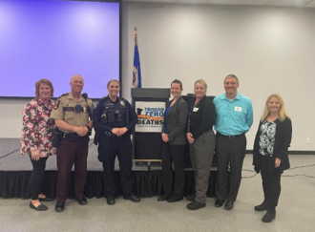
    - Seatbelt demonstration
    - State Patrol “Lasting Impact” video

  - Engineering
    - How crash data is used to plan roadway improvements
    - Help students plan a seatbelt survey for their neighborhood or city
- Host contests for students to incorporate traffic safety messaging:
  - Seatbelt challenge
  - PSA poster contest
  - PSA video commercial contest
  - TikTok Challenge
  - Bumper Sticker creation
  - Message board slogans
  - Billboard Challenge
- Have students pledge to “Promise to be belted”
- Work with local businesses who have drive-thru capabilities to promote seat belt compliance by offering coupons or discounts
- Use positive community norming information to create posters and other messages to reach their peers
  - Examples:
    - 94% of young people say they ALWAYS buckle up
    - 84% of young people say they WOULD speak up if the driver was texting
- Create seasonal displays or programs that promote safe driving and pedestrian habits.
  - Fall
    - Plan a bus safety display in front of the school for parents and students.
    - Organize a child safety “Buckle Up” campaign for parents and students.
    - Work with your county or city engineering office to plan a “Buckle Up” campaign in the school parking lot.
    - Share information about the “Hands-Free” law or other traffic safety laws.
  - Winter
    - Distribute information about winter driving practices.
    - Show the dangers of being exposed to the winter elements and how to be prepared when driving by creating a display of what materials.
    - Promote the responsibility of passengers in a car.
  - Spring
    - Ask local businesses in town to hang signage to prevent distracted driving.
    - Promote the IPROMise campaign.
    - Host a bike safety and pedestrian workshop.
    - Pair with an E to visit with middle school students about their responsibility with TZD.
  - Summer
    - Work with local E’s to have a display at the county fair promoting TZD.
    - Create table tents for local businesses to remind the public of road safety.
    - Hang signage promoting work zone safety.
    - Promote motorcycle safety and awareness for all.
- Create traffic safety messaging consistent with national or statewide events based on the DPS OTS TZD Enforcement Calendar. These messages could be included in emails, school dashboards, local newspapers, social media, etc.
  - Topics may include bike and pedestrian safety, distracted driving, impaired driving, motorcycle safety, seatbelt safety, speeding, work zone safety, etc.

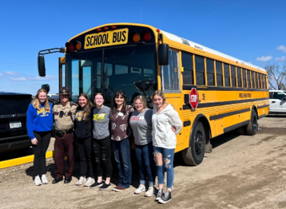
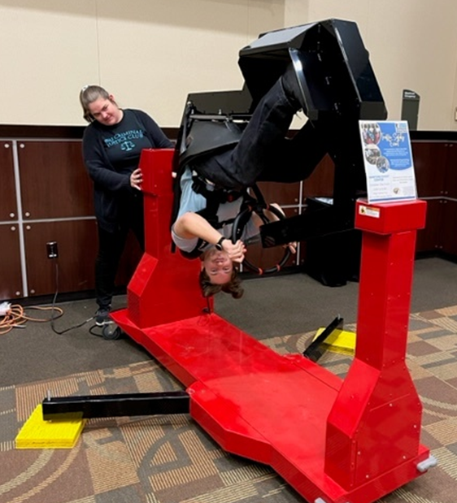
- POINT OF IMPACT (POI), PARENT AWARENESS PROGRAM
Description:
A 1.5 hour in-person awareness class for parents of pre-driving teens.
Objective:
Empower teens to be effective messengers by engaging parents of pre-driving teens to enhance their awareness of teen driving risks, laws, the important role they play in developing safer teen drivers, and available resources to help reduce crash risks.
Goal:
Reduce the number of crashes, injuries and deaths involving novice teen drivers by increasing parental awareness of teen driver safety issues and enhancing parent involvement in developing safer teen drivers.
Background:
Experts on young driver behavior are in substantial agreement that more effective parental involvement in mentoring novice drivers holds significant promise for further reducing young driver crashes. Source: Journal of Safety Research 34(1), (2003), 107-115
Understanding the risks associated with teen driving as well as appreciating the complexity of state laws governing novice drivers can be an eye-opening experience for a parent. Creating a greater awareness and understanding of policies such as graduated drivers’ licensing (GDL) laws will go a long way in assisting parents to help their children become safer drivers.
Source: Protecting Teen Drivers, A Guidebook for State Highway Safety Offices, (2010)
Teen crashes and risky driving behaviors are strongly linked with the way teens and parents communicate and approach rules about safety. Teens who said their parents set clear rules, paid attention to where they were going and whom they were with, and did so in a supportive way were:
-half as likely to crash
-twice as likely to wear seat belts
-71 percent less likely to drive while into 30 percent less likely to use a cell phone
while driving than teens who said their parents were less involved. Source: http://multivu.prnewswire.com/mnr/chop/39673/

Teen Crashes Have Predictable and Preventable Patterns:
- They are prone to making simple driving errors, often while speeding.
- They are twice as likely to crash at night.
- Crashes while driving to and from school, especially after school, and with other teens in the car is common.
- Teen passengers increase distractions and promote risk-taking behaviors.
In 2012 & 2013, the Minnesota POI pilot program included pre- & post-class surveys to evaluate changes in parental knowledge & confidence in understanding teen driving risks & laws.

The values below reflect the percentage of correctly answered questions.
Parents Knowledge of Laws: Pre-Class Post-Class ifference
Parental Consent Withdrawal: 95% 98.5% +3.5%
Texting: 85.5% 91% +5.5%
Cell Use: 91% 98% +7%
Seat Belts: 87% 97% +10%
Period of Greatest Risk: 82.5% 92% +9.5%
Passenger Restriction (first 6 months of licensure): 63% 87% +24%
Nighttime Restriction (first 6 months of licensure): 43% 86% +43%
Passenger Restriction (second 6 months of licensure): 23% 79.5% +56.5%
Confidence in Understanding Teen Driving Laws: 36% 74% +38%
Class evaluations showed:
- 99.5% of parents will use the information to help their teen become a safer driver
- 98.5% of parents would recommend the class to other parents
- 98% of parents rated the class Excellent or Good
Program Focus Areas:
1. Teen Driving Risks: Engage parents with an effective discussion about teen driving risks. Present basic crash data and discuss inexperience, teen passengers, seat belt use, risk-taking, nighttime driving, peer pressure, brain development, and other factors that contribute to teen crashes. When possible, reference a local teen driving incident to illustrate key points. Emphasize parental control and making decisions that prioritize safety over convenience.
2. Teen Driving Laws: Provide information on teen driving laws through discussion that engage parents’ interest. Elements of the graduated driver’s licensing (GDL) laws should be linked to teen driving risks to inform participants about why the laws were implemented. Discuss the shortcomings of the GDL laws (they don’t always reflect best practices). Law enforcement participation is important to explain laws and answer questions.
Emphasize parental control and making decisions that prioritize safety over convenience.
3. Family Rules and Parental Management: Discuss the important role parents play in developing safer teen drivers. Emphasis is placed on obtaining many hours of supervised driving experience in a variety of road and weather conditions prior to licensure. Parents should build on experience and introduce challenges in stages during the permit stage. Encourage parents to establish family driving rules that reduce their teens’ exposure to high risk situations, especially during their first year of licensure. Encourage parents to use a parent/teen driving contract. Emphasize the importance of following through with consequences for violating family driving rules.
Resources:
The Office of Traffic Safety has materials available to implement a class for parents and their soon-to-be teen drivers. To request the Point of Impact program materials, contact Kat Vue @ kat.vue@state.mn.us.
Point of Impact Leader’s Guide: (2020 update not yet available on OTS web site): https://dps.mn.gov/divisions/ots/teen-driving/Pages/default.aspx

- Teens Toward Zero Deaths Conference and State Conference
Giving teens additional opportunities to expand their traffic safety knowledge and skills beyond driver education programs, while building a broader awareness of local, state and national traffic safety issues, helps teens to develop safe driving behaviors and prevents crashes.
A TTZD Conference should incorporate the opportunity for teens to:
- learn about traffic safety with their peers,
- participate in roundtable discussions where teen voices matter,
- offer their opinion about what messaging is relevant to them,
- gain leadership opportunities through conference planning,
- connect with adults that have pursued a career related to traffic safety,
- explore career paths in the 4 E’s,
- expand social skills by networking with adults, and
- develop youth-adult partnerships with community members.

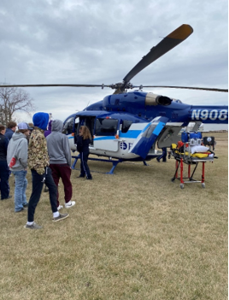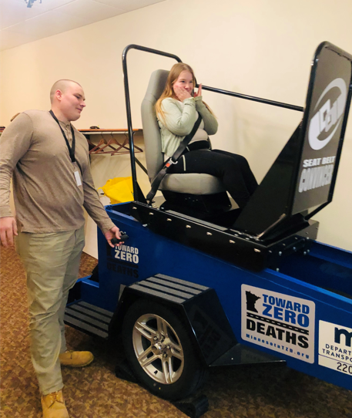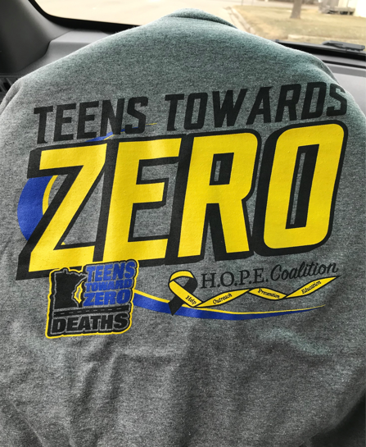

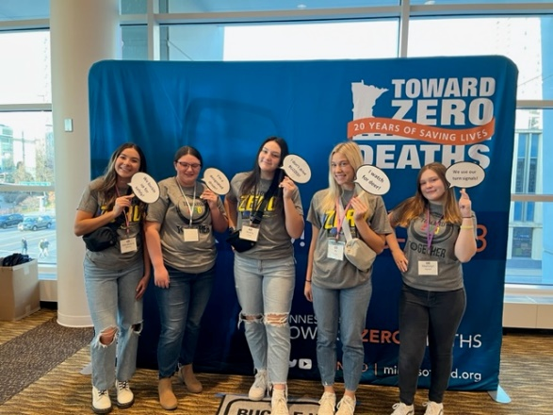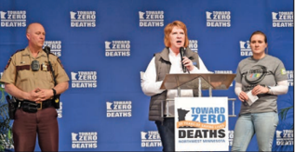

  - Event Planning
    - Teen TZD Committee/Sub Committee
      - Gather a team of teens and adults.
      - Set a planning schedule to determine how often you will meet to plan for the event.
      - Assign tasks for each member of the committee.
      - Reach out to:
        - “E” community members
        - regional TZD coordinator
        - statewide content experts
        - personal impact speaker
    - Budget
      - Determine a budget for the conference.
      - Consider sponsors that may support the event.
        - Make phone calls or send letters to different community organizations to ask for support.
      - Research any grant opportunities.
      - Consider fundraising options.
    - Schedule & Location
      - Find a place to hold the event, such as a community center or school.
      - Choose a date based on student and stakeholder commitments and schedules.
    - Content of Conference
      - Determine the purpose and/or theme.
      - Organize content and sessions.
      - Reach out to potential speakers and stakeholders to confirm availability.
      - Plan activities and breakout sessions.
      - Prepare a schedule or agenda.
      - Prepare an evaluation for attendees to provide feedback on the event.
      - Review logistics of the event (equipment required)
    - Supplies
      - Determine what materials are needed for planning, marketing and executing the event.
      - Create visual aids or displays with traffic signs, crash photos, etc.
      - Reach out to your regional TZD coordinator to see if traffic safety equipment is available for the event, such as distract-a-match, driving simulator, fatal vision goggles (distracted, drowsy, and/or impaired), pedal cart, seatbelt convincer, wheel of distraction, and other tools.
    - Marketing
      - Design outreach materials.
        - Incorporate a variety of advertising strategies, such as print, online (emails, social media), chalking, etc.
    - Set-up
      - Arrive early for set-up of all equipment and supplies.
      - Greet speakers and attendees.

    - Follow-up
      - Send thank you notes to speakers, volunteers, sponsors.
      - Review evaluation.

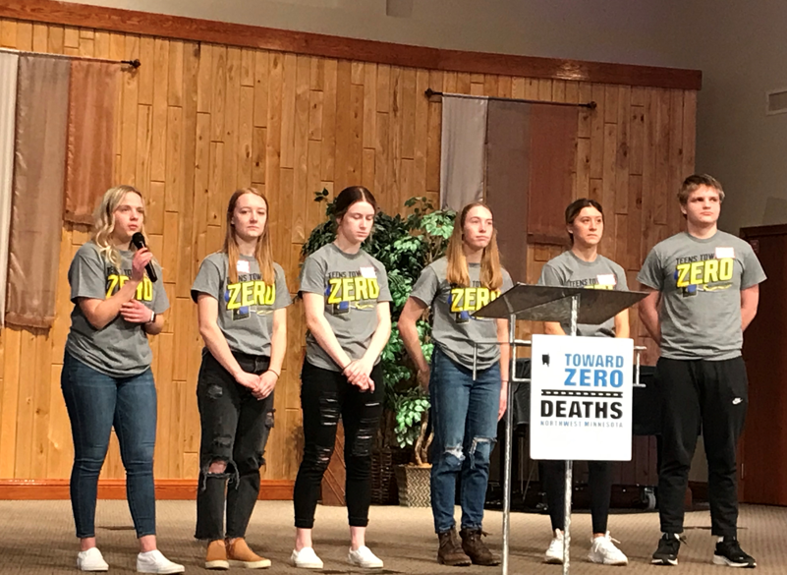

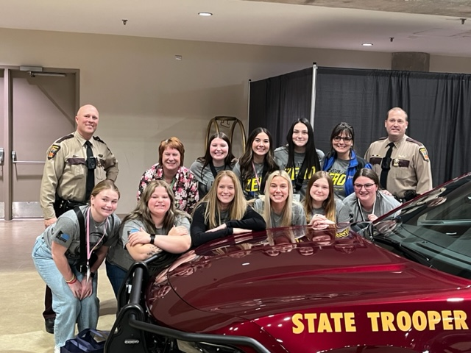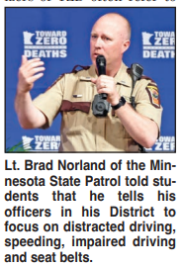

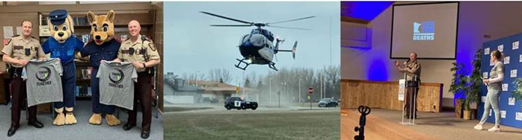
  - Example Agenda

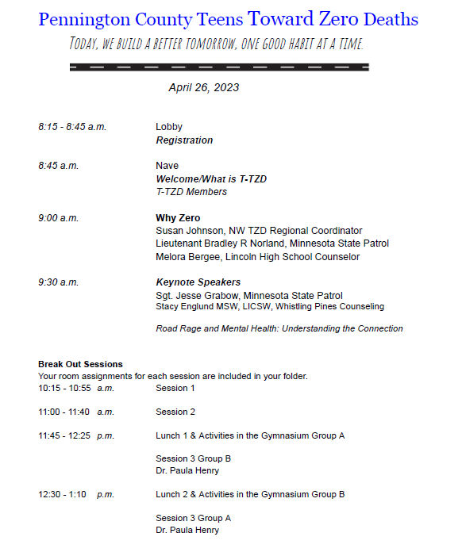

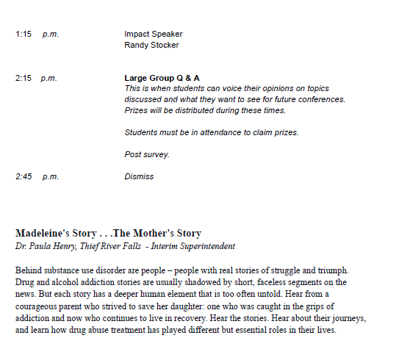

- Teen Data and Statistics
Each year in the United States, 4,000 teens die from traffic crashes and 400,000 teens are seriously injured. Traffic crashes are the second leading cause of teen deaths in Minnesota teens. Each year, more than 30 teens (ages 16-19) are killed on Minnesota roads. Teens are at greatest risk on the road due to inexperience, risk-taking behind the wheel, speeding and distracted driving.

Minnesota:
In Minnesota, from 2016 through 2018 teen drivers ages 16 – 19 were involved in:
- 109 fatal crashes
- 11,061 serious injury crashes
- 5,811 speeding related crashes
- 4,822 distracted driving related crashes
- 548 alcohol related crashes
- The crash rate for 16-19 year-olds is 29% higher than the crash rate of those 21+

Teen-driver crashes are similar to crashes overall when it comes to urban versus rural. However, it is worth noting there is a greater increased percentage for teen driver fatal rural crashes.

CRASH RATES PER 1,000 LICENSED MINNESOTA DRIVERS
(INCLUDES PERMITS), 2013-2017:
15 YEAR OLDS: 7.5
16 YEAR OLDS: 58.7
17 YEAR OLDS: 62.0
18 YEAR OLDS: 60.5
19 YEAR OLDS: 56.6
AVERAGE FOR ALL AGES: 32.4

Other Resources:
https://www.impactteendrivers.org/

The information below was taken from the Minnesota Strategic Highway Safety Plan.
See link for more information:
http://www.dot.state.mn.us/trafficeng/safety/shsp/shsp2014-2019.html

