Minnesota Teens Toward Zero Deaths Handbook
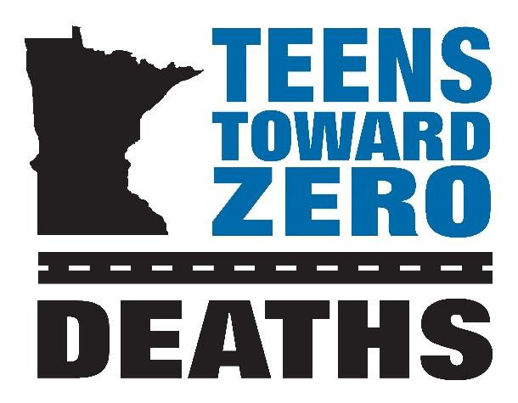
  - August 2026

Table of Contents
- Table of Contents 1
- Purpose of the Handbook 2
  - Teens Toward Zero Deaths Mission 2
- Resources and Information 3
  - Contact Information 3
  - Online Resources 4
  - Acronyms 4
- How to Get Started 5
  - Teen TZD Champions 5
  - TZD Committee 5
  - “E” Connection 5
  - Expenses 5
  - Responsibilities of TTZD 6
  - Evaluation 6
- Activities 7-10
- Teens Toward Zero Deaths Conference 11-14
  - Event Planning 11-12
  - Example Agenda 13-14
- Teen Data and Statistics 15-18

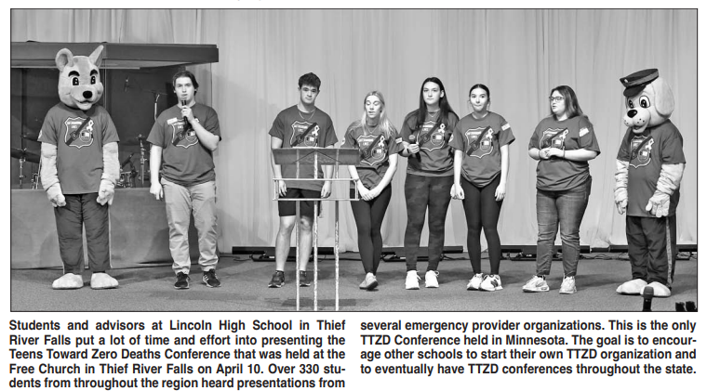
- Purpose of the Handbook
The purpose of this handbook is to provide an informational resource to assist in developing a Teens Toward Zero Deaths (TTZD) program in your local school, community, or region. This handbook outlines how to build the program as well as how to plan a regional conference. Regional conferences are designed to facilitate the implementation of TTZD in local communities and serve as a career exposition for students interested in the 4 E’s: Education, Emergency Medical Services (EMS), Enforcement, and Engineering. The goals of the TTZD program are to encourage traffic safety as a priority for teens, provide a method to bring traffic safety programs into communities, share successes of the Minnesota TTZD program, build relationships between schools, communities and the 4 E’s, and to network with other school and traffic safety advocates in the region.

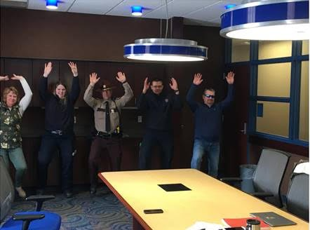
E's participating in a TikTok Video at TTZD Conference in Northwest Minnesota
  - Teens Toward Zero Deaths Mission
The Teens Toward Zero Deaths mission is to create a culture in which traffic fatalities and serious injuries are no longer acceptable. TTZD educates teenage drivers and school-age pedestrians about the responsibilities of keeping our roadways safe through youth advocacy groups and partnerships with local and regional E’s. TTZD efforts will be driven by data, best practices, research, and evaluation.

Resources and Information
  - Contact Information
Organization | Name | Title | Phone Number | Email
Lincoln High School TTZD | Rosaline  Groven | TTZD Program Coordinator | Office: 218-681-7463 #1113 | Rosaline.Groven@myprowler.org
Lincoln High School TTZD | Stacey Leake | TTZD Program Coordinator | Office: 218-681-7463 | Stacey.Leake@myprowlder.org
DPS Office of Traffic Safety | Michael  Hanson | Director and  TZD Co-Chair | Office: 651-201-7061  Cell: 763-276-0357 | Michael.Hanson@state.mn.us
Toward Zero Deaths | Annette Larson | State TZD Program & Operations Director | Office: 507-720-2101 | Annette.larson@state.mn.us
Toward Zero Deaths | Kristine Hernandez | Statewide TZD Communications & Marketing Director | Office: 507-286-7601  Cell: 507-273-0677 | Kristine.Hernandez@state.mn.us
Toward Zero Deaths | Scot  Edgeworth | East Metro Regional TZD Coordinator | Cell: 651-775-9496 | Scot.Edgeworth@state.mn.us
Toward Zero Deaths | Paige Lowery | West Metro Regional TZD Coordinator | Cell: 651-370-0210 | paige.lowery@state.mn.us
Toward Zero Deaths | Sarah McGeary-DeHaan | Southwest Regional TZD Coordinator | Cell: 320-231-5195 | Sarah.McGeary-DeHaan@state.mn.us
Toward Zero Deaths | Sue  Johnson | Northwest Regional TZD Coordinator | Cell: 218-766-5943 | Susan.Marie.Johnson@state.mn.us
Toward Zero Deaths | Rahya Geisler | Northeast Regional  TZD Coordinator | Cell: 651-201-7273 | Rahya.Geisler@state.mn.us
Toward Zero Deaths | Katy  Kressin | West Central Regional TZD Coordinator | Cell: 218-849-0048 | Katy.Kressin@state.mn.us
Toward Zero Deaths | Jessica Devens-Rodning | South Central Regional TZD Coordinator | Cell: 507-720-2101 | jessica.rodning@state.mn.us
Toward Zero Deaths | Bill Van Koevering | East Central Regional TZD Coordinator | Office: 507-286-7601  Cell: 507-273-0677 | bill.vankoevering@state.mn.us
Toward Zero Deaths | Jessica  Schleck | Southeast Regional  TZD Coordinator | Office: 507-286-7602  Cell: 507-696-8435 | Jessica.Schleck@state.mn.us
Online Resources
- Teens Toward Zero Deaths, Lincoln High School https://www.smore.com/eyz06
- Toward Zero Deaths www.minnesotatzd.org
- Toward Zero Deaths Regions www.minnesotatzd.org/initiatives/regions
- Minnesota Department of Health www.health.state.mn.us
- Department of Public Safety, Office of Traffic Safety www.dps.mn.gov/divisions/ots
  - Educational Materials https://dps.mn.gov/divisions/ots/educational-materials/
  - Teen Driving https://dps.mn.gov/divisions/ots/teen-driving/
- Minnesota Department of Transportation http://www.dot.state.mn.us/
- Minnesota State Patrol www.dps.mn.gov/divisions/msp
- Network of Employers for Traffic Safety www.trafficsafety.org
- Impact Teen Drivers Program www.impactteendrivers.org

Acronyms
- DPS: Department of Public Safety
- DPS OTS: Department of Public Safety, Office of Traffic Safety
- EMS: Emergency Medical Services
- MDH: Minnesota Department of Health
- MnDOT: Minnesota Department of Transportation
- MnDOT OTE: Minnesota Department of Transportation, Office of Traffic Engineering
- MSP: Minnesota State Patrol
- SHSP: Strategic Highway Safety Plan
- TZD: Toward Zero Deaths
- TTZD: Teens Toward Zero Deaths
- UMN CTS: University of Minnesota, Center for Transportation Studies

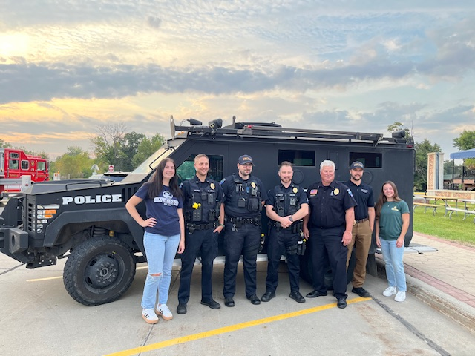

How to Get Started
- Champions for Teen TZD
Teen TZD champions are individuals who oversee the TTZD program within the school or organization. They are usually a teacher, somebody affiliated with the school, a community civic group, or other organization. When planning to integrate a TTZD program into the school environment, look for a well-respected adult, recognized by students, who are already affiliated with a student program within the community or school. It is important to work closely with the school(s) to create a TTZD program that is recognized as being vital to the safety and education of the student body. A willingness from school leaders, students, and the community to actively support and participate in the program is important for the success of the program.
  - Teen TZD Committee
Using an established organization, such as a club or student group, within the school is an excellent way to start forming a TTZD program. Creating a subgroup within an already existing organization is an option. Look for students who want to learn more about traffic safety, who are interested in implementing a traffic safety-related campaign, or who are interested in pursuing a career path in one of the E’s.
  - “E” Connection
Whether your county has an active TZD Safe Roads Coalition or not, members of the “E” community may be a good person to reach out to before getting started. Contact your local law enforcement agency, nearest State Patrol Office, EMS Service at a local hospital or clinic, local fire department, first responders, or your city or county engineering office. These groups are a valuable resource to start a TTZD program.
  - Expenses
Below is a list of typical operating expenses for TTZD programs. The list will change depending on the activities, events, or conference planned for your community.
- Printing of materials
- Materials cost, such as paper, posters, markers, etc.
- Advertising
- Door prizes

  - Teen TZD Commitment to Safe Roads Behavior
Establishing habits within individuals takes time and repeated application. For this reason, the TTZD program needs to be more than a one-day event. An ongoing platform, within the school and community, is best to prevent teen crashes and to ensure teens are practicing positive traffic safety behaviors, such as limiting distractions while driving and always wearing a seatbelt. Find more recommendations in the “Activities” section, which are created for driver awareness as well as for passengers and pedestrians.
  - Evaluation
Applying an evaluation component within a program helps to improve the program and demonstrate accountability of invested resources. Evaluation is a process that critically examines a program to assess the quality of the program’s activities, determine if the activities are well-designed and if the activities are working to their full potential. By incorporating an evaluation, it helps to determine if adjustments are needed in the program to improve the efforts. In addition, an evaluation demonstrates to stakeholders, such as individuals supporting efforts or sponsors, that the resources that were invested into the program were worthwhile. Validating the use of resources by providing evidence that goals were met, and services were delivered as promised is a program that will be viewed as successful.

Suggested Examples:
- TTZD students conduct a seatbelt survey to establish baseline data. The survey should be conducted in the Fall, prior to implementing activities. Activities focused on improved traffic safety will be implemented during the school year. In the Spring, another survey is conducted to determine if the traffic safety activities had an effect on students to improve their seatbelt rate.
- TTZD students conduct a survey to determine perceptions of traffic safety behaviors. Again, the survey should be conducted at the beginning and end of the school year to assess if traffic safety-related behaviors improved over time, after receiving messaging through TTZD efforts and activities that occurred during the school year.

- Activities
Here is a list of activities that schools have incorporated in their teen traffic safety programs:
- Impact Teen Drivers presentation to the 10th grade students (or all high school students if applicable).
- Host a mock crash event.
  - A guide for hosting an event is available on the DPS OTS Teen Driving website.
- Have the “grim reaper” visit the school.
- Ask the State Patrol office for photos from a crash scene. Incorporate photos throughout the building with a description of the crash.
- Visit the nearest junkyard and ask to borrow parts of crashed vehicles. Create displays within and outside the building. If you are able, match the photos and stories from the crash scenes with the actual car parts.
- Bring in an impact speaker, in conjunction with another traffic safety activity.
- Create a temporary memorial wall in the school for students and faculty to post pictures of loved ones lost to crashes on the road.
- Promote a yellow ribbon campaign.
  - Provide yellow ribbons for community members to tie around a tree for a lost loved one.
  - Using state and regional statistics, tie yellow ribbons in remembrance of those who perished on the roads on chairs and doors in the school building.
- Ask members of the “E” community to speak to students about traffic safety.
  - Education
    - Choose a specific topic based on student interest and select a traffic safety expert from your community to speak to students.
  - EMS
    - Demonstrate life-saving measures that may be required for crash victims.
  - Enforcement
    - Seatbelt demonstration
    - State Patrol “Lasting Impact” video
  - Engineering
    - How crash data is used to plan roadway improvements
    - Help students plan a seatbelt survey for their neighborhood or city
- Host contests for students to incorporate traffic safety messaging:
  - Seatbelt challenge
  - PSA poster contest
  - PSA video commercial contest
  - TikTok Challenge
  - Bumper Sticker creation
  - Message board slogans
  - Billboard Challenge
- Have students pledge to “Promise to be belted”
- Work with local businesses who have drive-thru capabilities to promote seat belt compliance by offering coupons or discounts such as banks and coffee/drink shops.
- Use positive community norming information to create posters and other messages to reach their peers.
  - Examples:
    - 94% of young people say they ALWAYS buckle up
    - 84% of young people say they WOULD speak up if the driver was texting

- Create seasonal displays or programs that promote safe driving and pedestrian habits.
  - Fall
    - Plan a bus safety display in front of the school for parents and students.
    - Organize a child safety “Buckle Up” campaign for parents and students.
    - Work with your county or city engineering office to plan a “Buckle Up” campaign in the school parking lot.
    - Share information about the “Hands-Free” law or other traffic safety laws.
  - Winter
    - Distribute information about winter driving practices.
    - Show the dangers of being exposed to the winter elements and how to be prepared when driving by creating a display of what materials.
    - Promote the responsibility of passengers in a car.
  - Spring
    - Ask local businesses in town to hang signage to prevent distracted driving.
    - Promote the IPROMise campaign.
    - Host a bike safety and pedestrian workshop.
    - Pair with an E to visit with middle school students about their responsibility with TZD.
  - Summer
    - Work with local E’s to have a display at the county fair promoting TZD.
    - Create table tents for local businesses to remind the public of road safety.
    - Hang signage that promotes work zone safety.
    - Promote motorcycle safety and awareness for all.
- Create traffic safety messaging consistent with national or statewide events based on the DPS OTS TZD Enforcement Calendar. These messages could be included in emails, school dashboards, local newspapers, social media, etc.
  - Topics may include bike and pedestrian safety, distracted driving, impaired driving, motorcycle safety, seatbelt safety, speeding, work zone safety, etc.

Programs:
POINT OF IMPACT (POI), PARENT AWARENESS PROGRAM
Description:
A 1.5 hour in-person awareness class for parents of pre-driving teens.
Objective:
Empower teens to be effective messengers by engaging parents of pre-driving teens to enhance their awareness of teen driving risks, laws, the important role they play in developing safer teen drivers, and available resources to help reduce crash risks.
Goal:
Reduce the number of crashes, injuries and deaths involving novice teen drivers by increasing parental awareness of teen driver safety issues and enhancing parent involvement in developing safer teen drivers.
Background:
Experts on young driver behavior agree that more effective parental involvement in mentoring novice drivers holds significant promise for further reducing young driver crashes. Source: Journal of Safety Research 34(1), (2003), 107-115
Understanding the risks associated with teen driving as well as appreciating the complexity of state laws governing novice drivers can be an eye-opening experience for a parent. Creating a greater awareness and understanding of policies such as graduated drivers’ licensing (GDL) laws will go a long way in assisting parents to help their children become safer drivers.
Source: Protecting Teen Drivers, A Guidebook for State Highway Safety Offices, (2010)
Teen crashes and risky driving behaviors are strongly linked with the way teens and parents communicate and approach rules about safety. Teens who said their parents set clear rules, paid attention to where they were going and whom they were with, and did so in a supportive way were:
  - Half as likely to crash
  - Twice as likely to wear seat belts
  - 71 percent less likely to drive while 30 percent less likely to use a cell phone while driving than teens who said their parents were less involved.
Source: http://multivu.prnewswire.com/mnr/chop/39673/

Teen Crashes Have Predictable and Preventable Patterns:
- They are prone to making simple driving errors, often while speeding.
- They are twice as likely to crash at night.
- Crashes while driving to and from school, especially after school, and with other teens in the car is common.
- Teen passengers increase distractions and promote risk-taking behaviors.

Program Focus Areas:
1. Teen Driving Risks: Engage parents with an effective discussion about teen driving risks. Present basic crash data and discuss inexperience, teen passengers, seat belt use, risk-taking, nighttime driving, peer pressure, brain development, and other factors that contribute to teen crashes. When possible, reference a local teen driving incident to illustrate key points. Emphasize parental control and make decisions that prioritize safety over convenience.
2. Teen Driving Laws: Provide information on teen driving laws through discussion that engages parents’ interest. Elements of the graduated driver’s licensing (GDL) laws should be linked to teen driving risks to inform participants about why the laws were implemented. Discuss the shortcomings of the GDL laws (they don’t always reflect best practices). Law enforcement participation is important to explain laws and answer questions.
Emphasize parental control and make decisions that prioritize safety over convenience.
3. Family Rules and Parental Management: Discuss the important role parents play in developing safer teen drivers. Emphasis is placed on obtaining many hours of supervised driving experience in a variety of road and weather conditions prior to licensure. Parents should build on experience and introduce challenges in stages during the permit stage. Encourage parents to establish family driving rules that reduce their teens’ exposure to high-risk situations, especially during their first year of licensure. Encourage parents to use a parent/teen driving contract. Emphasize the importance of following through with consequences for violating family driving rules.
In 2012 & 2013, the Minnesota POI pilot program included pre- & post-class surveys to evaluate changes in parental knowledge & confidence in understanding teen driving risks & laws.

The values below reflect the percentage of correctly answered questions.
Parents’ Knowledge of Laws: Pre-Class Post-Class Difference
Parental Consent Withdrawal: 95% 98.5% +3.5%
Texting: 85.5% 91% +5.5%
Cell Use: 91% 98% +7%
Seat Belts: 87% 97% +10%
Period of Greatest Risk: 82.5% 92% +9.5%
Passenger Restriction (first 6 months of licensure): 63% 87% +24%
Nighttime Restriction (first 6 months of licensure): 43% 86% +43%
Passenger Restriction (second 6 months of licensure): 23% 79.5% +56.5%
Confidence in Understanding Teen Driving Laws: 36% 74% +38%

Class evaluations showed:
- 99.5% of parents will use the information to help their teens become safer drivers.
- 98.5% of parents would recommend the class to other parents.
- 98% of parents rated the class Excellent or Good.

Resources:
The Office of Traffic Safety has materials available to implement a class for parents and their soon-to-be teen drivers.
Point of Impact Leader’s Guide: (2020 update not yet available on OTS web site): https://dps.mn.gov/divisions/ots/teen-driving/Pages/default.aspx
- Teens Toward Zero Deaths Conference
Giving teens additional opportunities to expand their traffic safety knowledge and skills beyond driver education programs, while building a broader awareness of local, state and national traffic safety issues, helps teens to develop safe driving behaviors and prevents crashes.
A TTZD Conference should incorporate the opportunity for teens to:
- Learn about traffic safety with their peers,
- Participate in roundtable discussions where teen voices matter,
- Offer their opinion about what messaging is relevant to them,
- Gain leadership opportunities through conference planning,
- Connect with adults that have pursued a career related to traffic safety,
- Explore career paths in the 4 E’s,
- Expand social skills by networking with adults, and
- Develop youth-adult partnerships with community members.

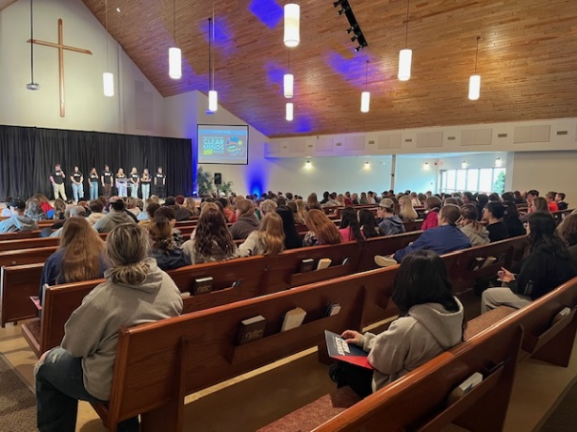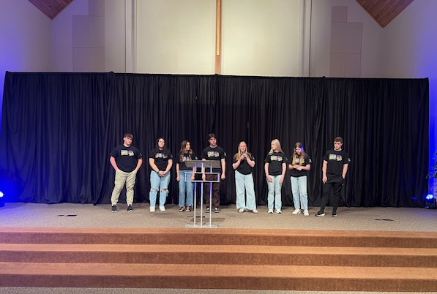

  - Event Planning
- Teen TZD Committee/Sub Committee
  - Gather a team of teens and adults.
  - Set a planning schedule to determine how often you will meet to plan for the event.
  - Assign tasks for each member of the committee.
  - Reach out to:
    - “E” community members
    - regional TZD coordinator
    - statewide content experts
    - Personal Impact Speaker
- Budget
  - Determine the budget for the conference.
  - Consider sponsors that may support the event.
    - Make phone calls or send letters to different community organizations to ask for support.
  - Research any grant opportunities.
  - Consider fundraising options.
- Schedule & Location
  - Find a place to hold the event, such as a community center or school.
  - Choose a date based on student and stakeholder commitments and schedules.
- Content of Conference
  - Determine the purpose and/or theme.
  - Organize content and sessions.
  - Reach out to potential speakers and stakeholders to confirm availability.
  - Plan activities and breakout sessions.
  - Prepare a schedule or agenda.
  - Prepare an evaluation for attendees to provide feedback on the event.
  - Review of logistics of the event (equipment required)
- Supplies
  - Determine what materials are needed for planning, marketing and executing the event.
  - Create visual aids or displays with traffic signs, crash photos, etc.
  - Reach out to your regional TZD coordinator to see if traffic safety equipment is available for the event, such as distract-a-match, driving simulator, fatal vision goggles (distracted, drowsy, and/or impaired), pedal cart, seatbelt convincer, wheel of distraction, and other tools.
- Marketing
  - Design outreach materials.
    - Incorporate a variety of advertising strategies, such as print, online (emails, social media), chalking, etc.
- Set-up
  - Arrive early for set-up of all equipment and supplies.
  - Greet speakers and attendees.
- Follow-up
  - Send thank you notes to speakers, volunteers, sponsors.
  - Review evaluation.

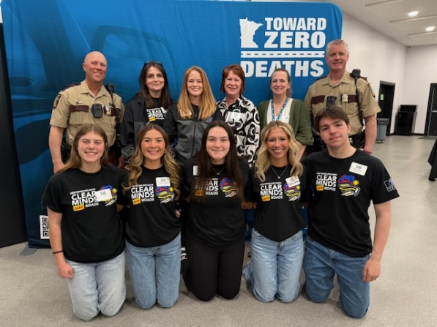
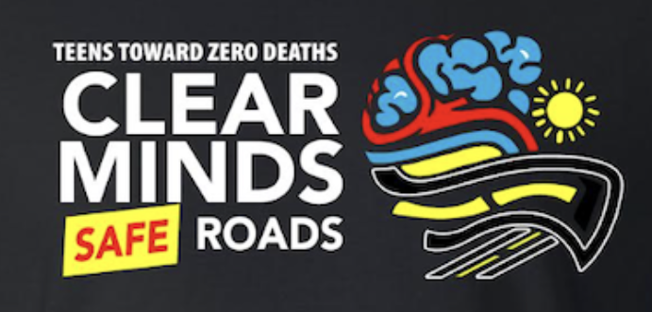

2026 Teen TZD Conference Agenda:


2026 POWER SESSIONS
Human Trafficking/Internet Safety
Human trafficking and child exploitation are a real thing, and it does happen in Thief River
Falls, MN. We will speak on real-life investigations that have occurred in our area, tell in detail how kids are groomed on social media platforms, and give helpful ideas on what to look for if caught in these situations.

Toxic Relationships: How to Spot Them; Protect Yourself
In this session, you’ll learn what actually makes a relationship toxic, what gaslighting and manipulation look like, how to set boundaries without feeling guilty, protect your mental health, when and how to ask for help and so much more.

CPR & AED/Emergencies for Flight
In this interactive session, students will learn the critical steps during a cardiac emergency. Participants will explore when and how to use an Automated External Defibrillator (AED), understand the importance of CPR, and know why calling 911 is essential. Through hands-on practice, students can operate an AED and experience what it's like to perform CPR, gaining confidence in their ability to respond effectively in an emergency.

The Power of Choice: How Your Decisions Shape Your Brain & Future
Come and join us for an engaging overview of how the developing teen brain works and how substances like alcohol, vaping/nicotine, cannabis, caffeine, and opioids can impact memory, decision-making, motivation, and long-term health. It emphasizes that most teens are not using substances, correcting misperceptions, and empowering healthy decision-making

Real Life. Real Emergencies. Real Skills
What would you do if someone collapsed, started choking, or was seriously hurt? This session gives you the confidence to act instead of freeze. You’ll learn how to handle common emergencies like bleeding, burns, and choking using straightforward techniques that could help save a friend, teammate, or family member.

What happens at a crash scene?
When a crash happens, the impact goes far beyond damaged vehicles. This presentation walks students through what law enforcement, emergency responders, and victims experience at a crash scene. It highlights the emotional, physical, and legal consequences of risky driving behaviors, encouraging students to make safer choices before they ever get behind the wheel.

Recognizing and Recovering from Stress
In this session we will discuss how difficult and stressful experiences impact our mind, body, and nervous system. We will explore what emotional/mental triggers are, how they are developed, and how they show up in our lives. Each one of us faces daily stress and pressure. Together we will learn practices to grow your emotional capacity, recognize when you are overwhelmed, and practice activities and skills to help you feel peace and calm. It is possible to feel peaceful even when chaos and stress are all around.

Grief
Have you ever dealt with the death of an important person in your life? Has someone moved away and you can't see them anymore? Has your family lost a pet? If so, here is an opportunity to learn about the grief/loss process and how to deal with the emotions related to it.

Traumatic Injuries & Stop the Bleed: Strategies for Bystander Life-Saving Care
Participants will explore the critical role of bystanders in the chain of survival and learn the fundamental principles of bleeding control. This session is designed to prepare individuals to act as immediate responders in medical emergencies involving traumatic injury. By understanding how to recognize life-threatening bleeding and applying standardized intervention strategies, attendees can gain the knowledge necessary to provide aid until professional emergency medical services arrive.

Building Bridges – Test Your Bridge-Building Skills
Discover the extraordinary potential of STEM! The fusion of science, technology, engineering, and mathematics has become a priority in education and numerous other domains. Its influence is so profound that it has been acclaimed as indispensable for the future, exerting a profound impact on children, diversity, the workforce, and the economy, among countless other realms. Embark on an exhilarating journey where math, science, technology, and engineering become sources of joy and stimulation. Join us in an exciting competition against other groups, where you can experience firsthand the thrill of pushing your limits and exploring STEM's boundless possibilities.

CAREER SESSIONS
- Firefighters: A Noble Profession
- EMS- Not only a Career, but a Passion
- So You Want to Be a Therapist? The Real Story.
- Life Behind the Badge
- Flight Paramedic - Sanford AirMed
- Content Creation, Public Speaking, YouTube & Podcasts
- Owner Relearn Relationship LLC
- The Dynamic World of Nursing
- What the $%/8 is a Civil or Traffic Engineer?
- Physical Therapist
- Mental Health Professional or LICSW
- Powering Communities: Careers in Electrical Linework & Energy

- Teen Data and Statistics
Each year in the United States, 4,000 teens die from traffic crashes, and 400,000 teens are seriously injured. Traffic crashes are the second leading cause of teen deaths in Minnesota teens. Each year, more than 30 teens (ages 16-19) are killed on Minnesota roads. Teens are at greatest risk on the road due to inexperience, risk-taking behind the wheel, speeding and distracted driving.

Minnesota Teen Crash Facts for 2020 (15-19 years)

39 teens died in traffic crashes, 3,673 were injured

There were 44 fatal crashes and 9,236 crashes involving teens. 50 people died in “teen involved” crashes

“Teen involved” means that a teen driver was involved in the crash involving any motor vehicle. It does not mean that they caused the crash.

Minnesota teen drivers continue to be overrepresented in traffic crashes due to driver inexperience, distractions, speeding/risk-taking, and seat belt non-use. The greatest crash risk occurs during the first months of independent driving. The good news is that progress has been made. Laws such as no cell phone use, no texting, primary seat belt, and nighttime and passenger limitations have helped reduce teen traffic deaths and injuries.

In 2005, 21.9% of all traffic crashes were “teen involved”. In 2020 teens
represent 6% of drivers and 16% of crashes

Contributing factors in teen crashes: as listed most often by officers on the scene:

      - Failure to yield
      - Following too closely
      - Driver inattention/distraction

  - Of the 15 teen drivers killed, 4 teens were tested for alcohol, and all were over the legal limit
  - Male and female drivers had about the same crash history at the ages of 16 and 17 but after that, male drivers crashed more than females.

Other Resources:
https://www.impactteendrivers.org/

