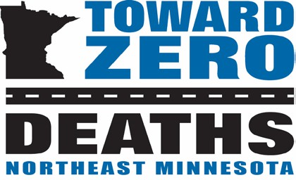
Northeast Minnesota Toward Zero Deaths

Mission:
To create a culture for which traffic fatalities and serious injuries are no longer acceptable through the integrated application of education, engineering, enforcement and emergency medical and trauma services. These efforts will be driven by data, best practices and research.

Values:
- Continuous improvements,
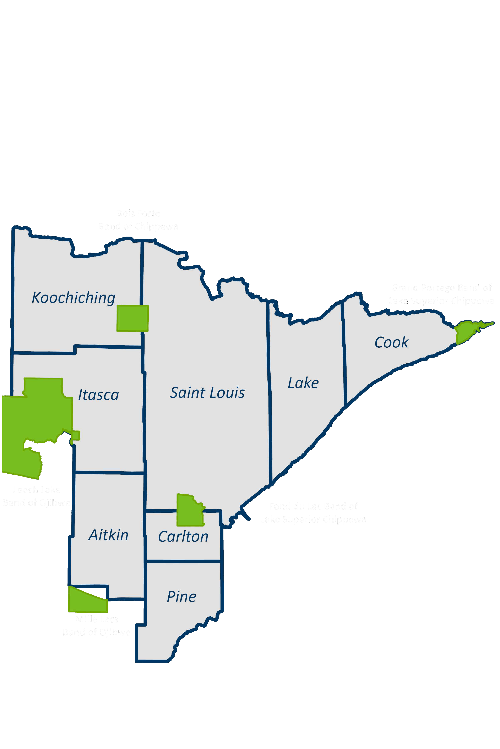
- Engage partners and
- Evidence-based approaches.

The Northeastern Minnesota Toward Zero Deaths (TZD) program began in 2010. The counties involved include Aitkin, Carlton, Cook, Itasca, Koochiching, Lake, Pine, St. Louis.

The leading types of crash resulting in deaths and severe injuries include:

Careless/negligent driving
- Failure to keep in proper lane

The leading causes of deaths and severe injuries in Northeastern Minnesota include:

Alcohol
- Distraction
- Speed and Aggressive Driving
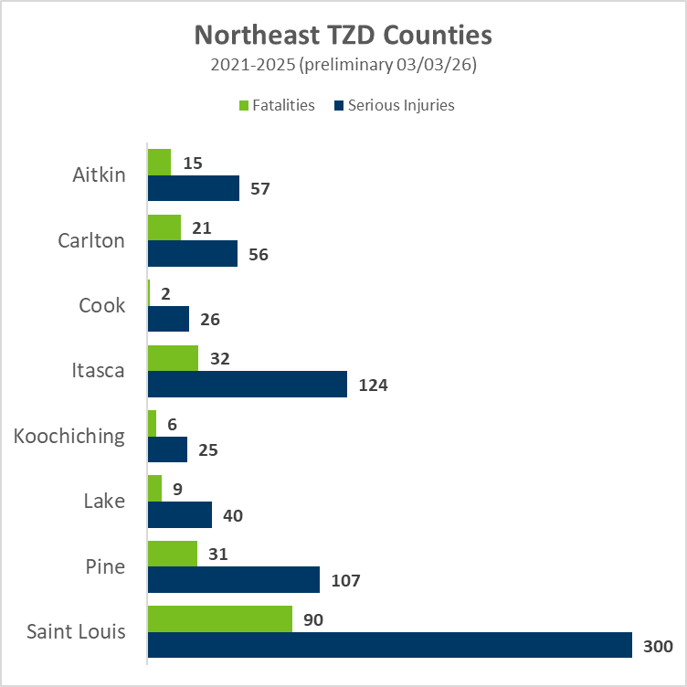
- Lack of Seatbelt use

The Northeastern Minnesota TZD program is
led by a steering committee comprised of the
“5 Es:”
- Enforcement
- Engineering
- Education
- Emergency Medical and Trauma Services
- Everyone - Community members

Northeast Minnesota TZD Leadership Contacts

Andy Johnson, PE Capt. Peter Goman Capt. Jason Engeldinger Rahya Geisler
MnDOT District Engineer Minnesota State Patrol Minnesota State Patrol NE MN TZD Coordinator
218-750-0937 218-302-6100 218-735-3721 218-830-1477
andy.johnson@state.mn.us peter.goman@state.mn.us jason.engeldinger@state.mn.us rahya.geisler@state.mn.us

Carol Burr Dave Brooks
Planning & Community Development Director Operations Supervisor, Mayo Ambulance
Bois Forte Tribal Community; 218-404-4465 brook.david1@mayo.edu; 218-628-9324
cburr@boisforte-nsn.gov www.minnesotatzd.org

