


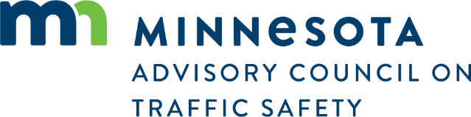
QUARTERLY IMPACTS REPOR
Restoring ACTS funding to provide
stronger community impact
The Advisory Council currently funds approximately 21 local Safe Roads Coalitions across the state, while another 45 active coalitions operate without state grant assistance. These “boots
on the ground” community-based partnerships are committed to reducing fatal and serious-injury traffic crashes through localized strategies. For example, in 2025, Le Sueur County’s JOYRIDE program provided more than 2,220 reliable, alcohol-free rides home, directly preventing potential DWI incidents. Additionally, the Impact Teen Drivers program reached 4,019 students in 2025 across Minnesota, positively changing teen attitudes toward
safe driving.
In 2027, the Advisory Council will be asking the legislature to restore its annual base budget from $1.1 million to the $2 million originally authorized in 2023. Restoring this $900,000 would allow the Advisory Council to greatly expand its grant program to serve additional Safe Roads Coalitions and further their impact across the state. Expanding the network of coalitions will help the Advisory Council develop solutions to local traffic safety challenges, accelerating progress toward zero fatalities and injuries on Minnesota’s roads.
- Speed-related fatalities to date are at least 20% less
than every other year since 2020, including 51% less
than in 2021.
- Distraction-related fatalities are one more than
last year, but at least 21% less than every other year
since 2020.
- Motorcycle fatalities to date are 31% more than last year and 5% more than in both 2023 and 2024 but are 20% less than in 2022.
Minnesota Traffic Fatality Data Snapshot
Through September 27, 2026
QUARTERLY IMPACTS REPORT October 2026
Updating legislation for safe, quick incident clearance on MN roads
Traffic incident management strategies ensure safe, quick clearance — swiftly removing vehicles and debris to prevent secondary crashes, protect emergency responders, and ease congestion. State legislation supports this through “Move It” laws, requiring drivers to clear travel lanes after minor crashes, and “Remove It” laws, granting responders authority to clear roadways with liability protection for good-faith actions.
Minnesota’s current law limits vehicle removal authority to the metro area and lacks liability protections for responders. In the 2027 legislative session, the Advisory Council will recommend updates to expand driver and responder removal authority statewide, engage local law enforcement and public works, and build stakeholder consensus with the towing and freight industries.

The Advisory Council on Traffic Safety was established by the Minnesota Legislature in 2023 to advise the governor and the commissioners of public safety, transportation, and health on traffic safety policies, programs, and services. To learn more and subscribe to our updates, visit MNTrafficSafetyCouncil.org or scan the QR code.
363*
285
300
2025 TOTAL
2025 YTD
2026 YTD

