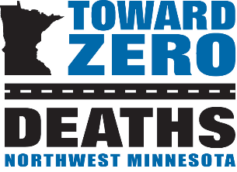
Northwest Minnesota Toward Zero Deaths

Mission:
To create a culture in which traffic fatalities and serious injuries are no longer acceptable through the integrated application of education, engineering, enforcement and emergency medical and trauma services. These efforts will be driven by data, best practices and research.

Values:
- Continuous improvements,
- Engage partners and
- Evidence-based approaches.
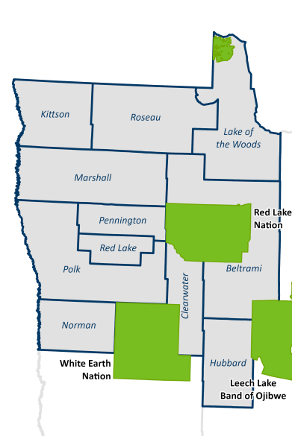

The Northwest Minnesota Toward Zero Deaths (TZD) program began in 2008. The counties involved include Beltrami, Clearwater, Hubbard, Kittson, Lake of the Woods, Marshall, Norman, Pennington, Polk, Red Lake and Roseau.

The leading cause of deaths and severe injuries in northwest Minnesota include:

Alcohol,
- Distraction,
- Speed and
- Lack of Seatbelt use.

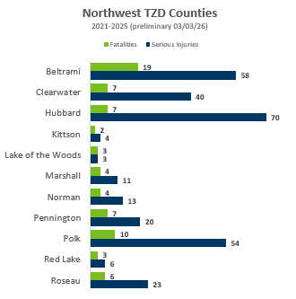

The leading type of crash resulting in deaths and severe injuries include:

Run-off-Road
- Intersection-related

The Northwest Minnesota TZD program is led by a steering committee comprised of the “4 Es:”
- Enforcement
- Engineering
- Education
- Emergency Medical and Trauma Services

Northwest Minnesota TZD Leadership Contacts
Engineering  Bill Pirkl  MnDOT District Engineer | Enforcement  Capt. Brian Cheney Minnesota State Patrol | Education/EMS  Sue Johnson  TZD Regional Program Coordinator
218-766-3252 | 218-683-8411 | 218-766-5943
bill.pirkl@state.mn.us | brian.cheney@state.mn.us | susan.marie.johnson@state.mn.us

www.minnesotatzd.org

